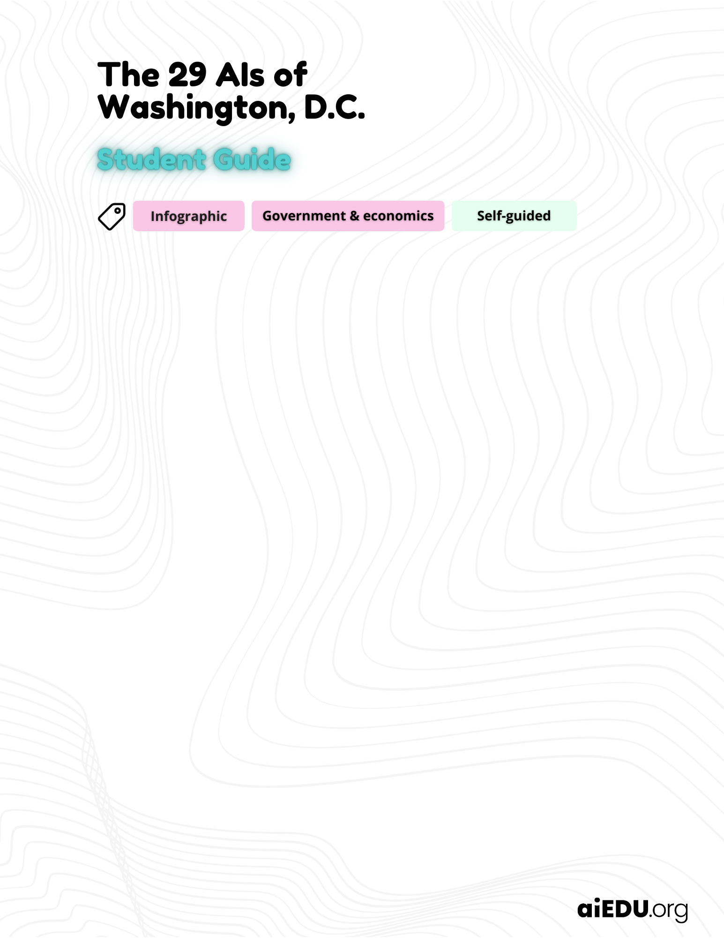

Add your answers in the green boxes below.

Making decisions
 | How do governments make decisions like how long someone goes to jail, who gets food assistance, and who deserves free community college?

 | The definition of artificial intelligence (AI)
Check out the definition and interesting examples of AI at
🔗 aiedu.org/ai-in-five. Make sure to read the page before moving on.

The definition of automated decision system
A computer program that makes decisions based on data and rules and aims to replace human decision-making.

Diverse experiences of AI
Experience AI through someone else’s eyes
Throughout this project, you’ll be referencing a report called Screened & Scored in Washington, D.C., which was written by the Electronic Privacy Information Center.

🔗 View the Screened & Scored in Washington, D.C. report here.

Choose one person’s experience to read about:
- Juan Hernandez (pages 6-10)
- CeeCee Montgomery (pages 31-35)

As you read, think about:
- How was the person’s experience positively and negatively affected by AI?
- What do you think would change about their experience if the AI was never used?

How was either Juan or CeeCee positively and negatively affected by AI?

What do you think would change about Juan or CeeCee’s experience if the AI was never used?

Examine AI systems
Flip to pages 12-14 in the Screened & Scored report, which has a table of AIs used in Washington, D.C.

🔗 View the Screened & Scored in Washington, D.C. report here.

- Examine each system and consider who uses it and why.
- Choose two systems that interest you. In the green boxes below, explain who would be affected by the system, what benefits it could have, and what could go wrong

Name of System 1:
What kinds of people would this affect?

If the system worked perfectly, how would it benefit this person?

If the system messed up, what harm could it cause?

Name of System 2:
What kinds of people would this affect?

If the system worked perfectly, how would it benefit this person?

If the system messed up, what harm could it cause?

Creating a PSA

Create a Public Service Announcement (PSA)
Directions
The goal of this PSA is to raise awareness among citizens of D.C. about how AI systems are used in their community.
- Choose one of the two imaginary people below to focus on:

 | 
Hector, an 18-year-old senior at a local high school who is excited to graduate. He moved out this year because he wanted to be on his own. He’s crashing with a friend right now but is looking for his own apartment. He did get in trouble with the law a few times freshman year, and spent a bit of time in juvenile detention, but all that is behind him. | Celine, a 41-year-old business owner who owns two buildings downtown. She got unemployment benefits before starting her business last year. She lives in an area with gang activity, so she tries to keep her head down. She injured her back in a car accident recently and has a prescription for pain medication.

- Choose 5 systems from the Screened & Scored report that you think might affect their life
- Create a physical or virtual infographic (on paper or in Google Slides or Canva) explaining to them how these systems might affect them. Put the person at the center of your infographic and help readers visualize how these systems affect their lives.
- Make a conclusion at the bottom of your poster: how are people’s lives affected by these systems in Washington, D.C.?

Tips & tricks
- Make your poster visual: show how the person would be affected
- Use any statistics and information you can find in the report to support your ideas

When you’re done
If you have time left over, check out the table below of automated decision systems used in New York City. What similarities and differences do you notice?

🔗 Automated Decision Systems in New York City

